Stærðfræði

Múlan



Nafn __________________________



Hvað eru margar myndir af



_______

______

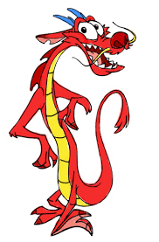

 ________

_____

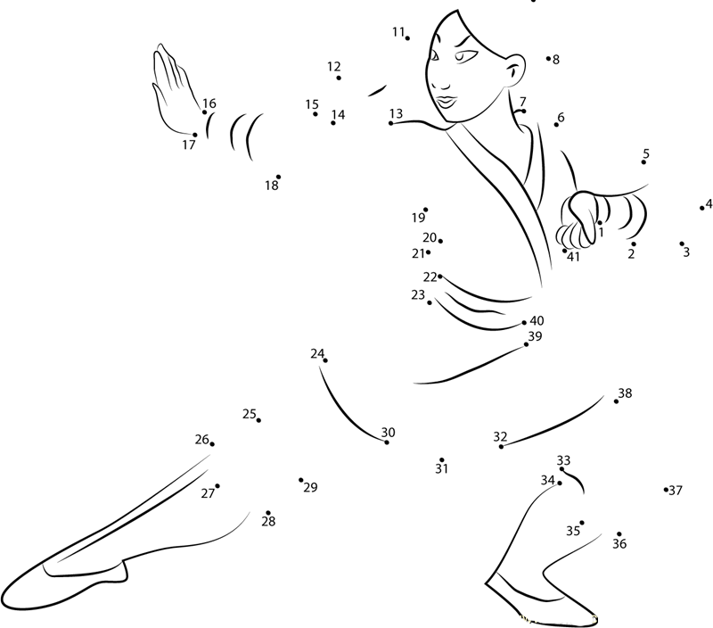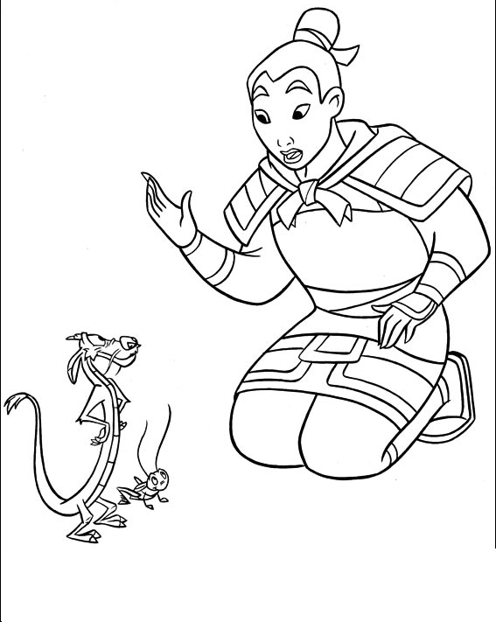   
 Settu utan um   
 **stærri** töluna

|  |  |
| --- | --- |
| 9 | 2 |
| 3 | 7 |
| 8 | 5 |
| 1 | 6 |
| 0 | 2 |
| 4 | 1 |
| 5 | 9 |



+ = ______

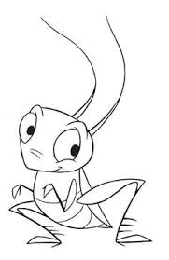

 +  = _______





 + = _____





  
  
 +

= _____



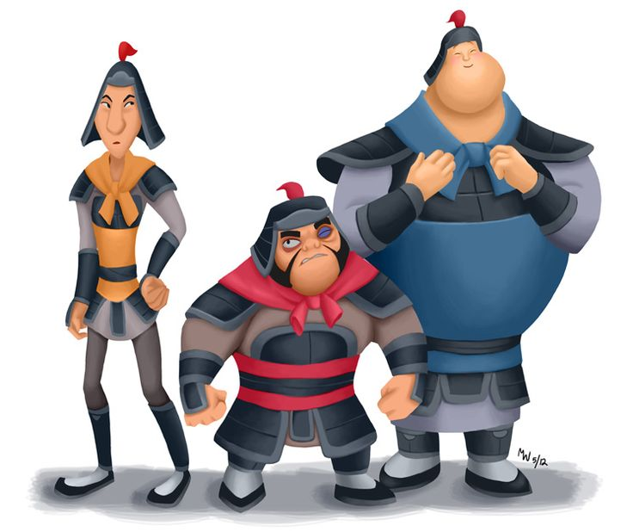

   
  
+ =___

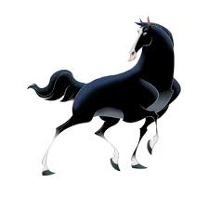

+ = ______

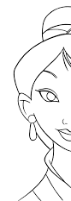Settu utan um Teiknaðu   
 **minni** töluna

|  |  |
| --- | --- |
| 6 | 1 |
| 9 | 2 |
| 4 | 7 |
| 5 | 9 |
| 4 | 2 |
| 8 | 4 |
| 3 | 9 |

1 ____________________

2 ____________________

3 ____________________

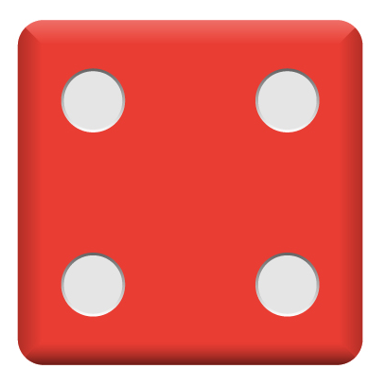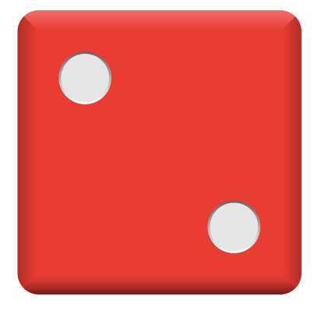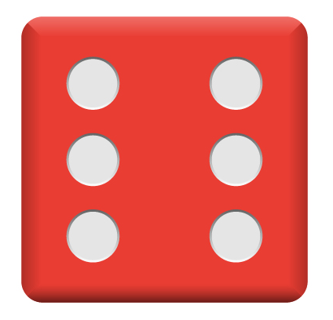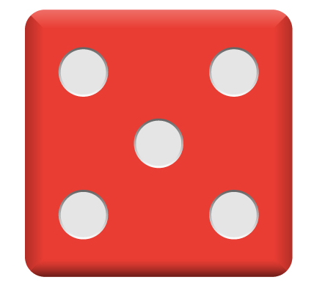Tengdu saman tölu og tening

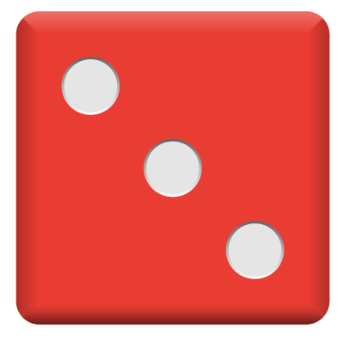

1 2 3 4 5 6

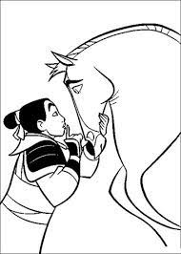

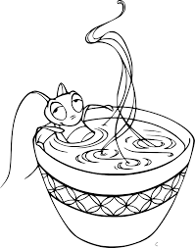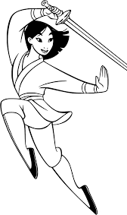

4 ___________________

5 ____________________

6 ____________________