

|  |  |  |  |
| --- | --- | --- | --- |
| **júní** |  |  |  |
| **3. – 9.** |  |  |  |
| **10. – 16.** |  |  |  |
| **17. - 22.** |  |  |  |
| **24. – 30.** |  |  |  |

Bækur

_________________________

_________________________



_________________________

|  |  |  |  |
| --- | --- | --- | --- |
| **júlí** |  |  |  |
| **1. – 7.** |  |  |  |
| **8. – 14.** |  |  |  |
| **15. - 21.** |  |  |  |
| **22. – 28.** |  |  |  |
| **29. – 04.** |  |  |  |

********

Bækur

_________________________

_________________________

_________________________

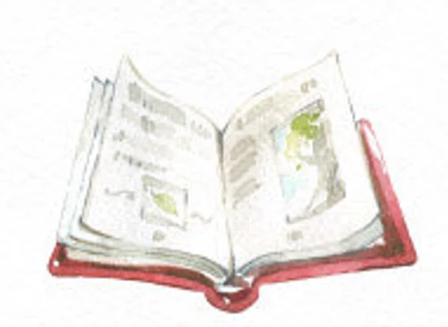

|  |  |  |  |
| --- | --- | --- | --- |
| **ágúst** |  |  |  |
| **5. – 11.** |  |  |  |
| **12. – 18.** |  |  |  |
| **19. – 25.** |  |  |  |
| **26. – 31.** |  |  |  |

Bækur

________________

________________

________________



****Nafn _____________________

**Ég les 3 sinnum í viku   
til að missa ekki niður lestrargetuna.**

**Merktu x í reitinn þegar þú hefur lesið.**

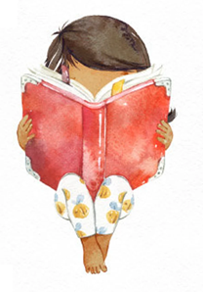

**Bestu lestrarkveðjur í sumarfríinu**